General:
- Grouping can be done by color=”columnname”.
- Multiple plots in one:
  - Create figure: fig = plotly.graph_objects.Figure()
  - Add graphs withs: fig.add_trace(go.Scatter(x=…, y=…, …))

Imports:
- import plotly.express as px
- import pandas as pd
- import plotly.figure_factory as ff

scatter plot  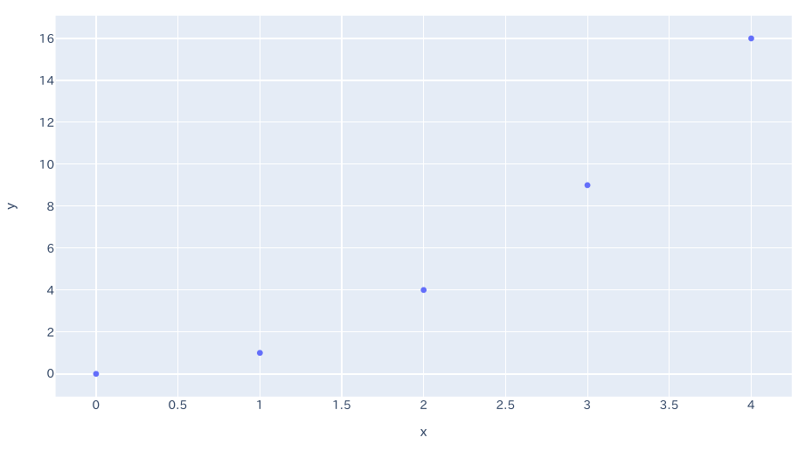  px.scatter(x=[0, 1, 2, 3, 4], y=[0, 1, 4, 9, 16]) | bubble chart ( = scatter plot with different dot sizes)  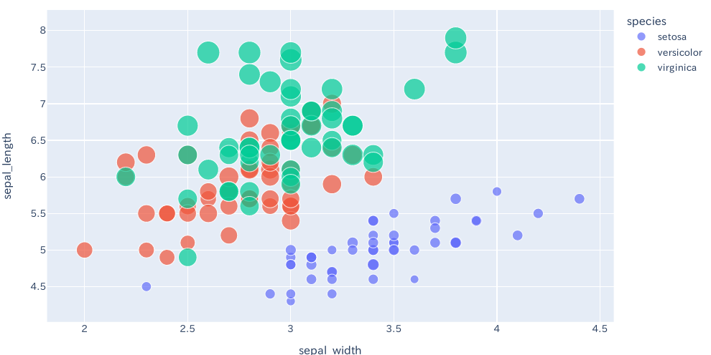  px.scatter(df, x="dataX", y="dataY", color="species",size='petal_length')
scatter plot with continuous coloring  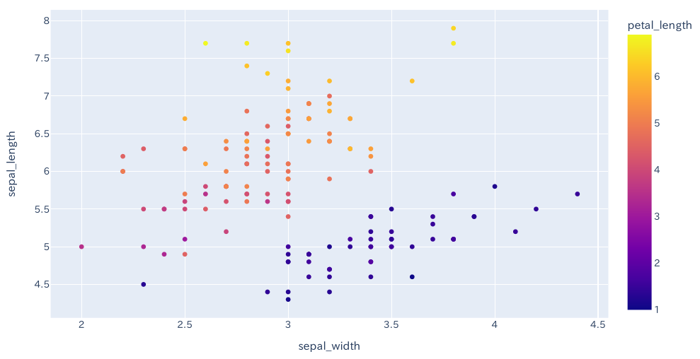  px.scatter(df, x="sdataX ", y="dataY", color='petal_length') | scatter plot with dot shapes grouped  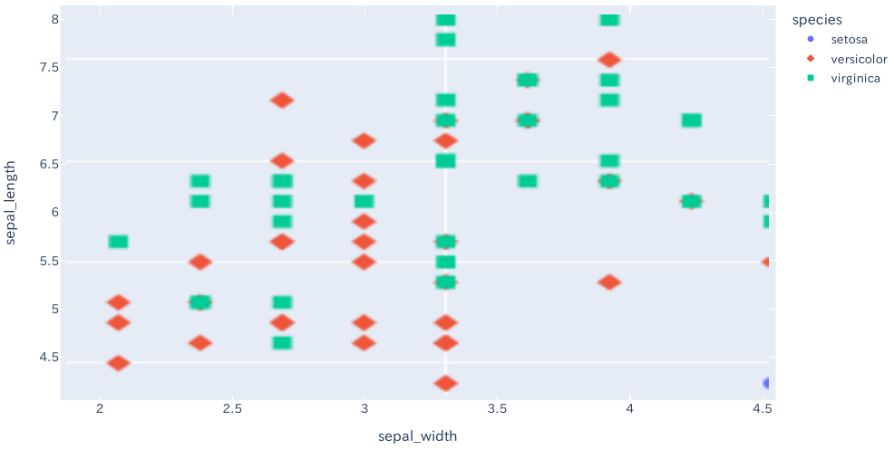  px.scatter(df, x="dataX", y="dataY", color="species", symbol="species")
scatter plot with (x and y) error bars  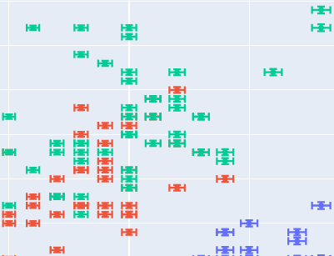  px.scatter(df, x="dataX", y="dataY", color="species", error_x="e", error_y="e") | Marginal Distribution Plot (distribution plots on the side)  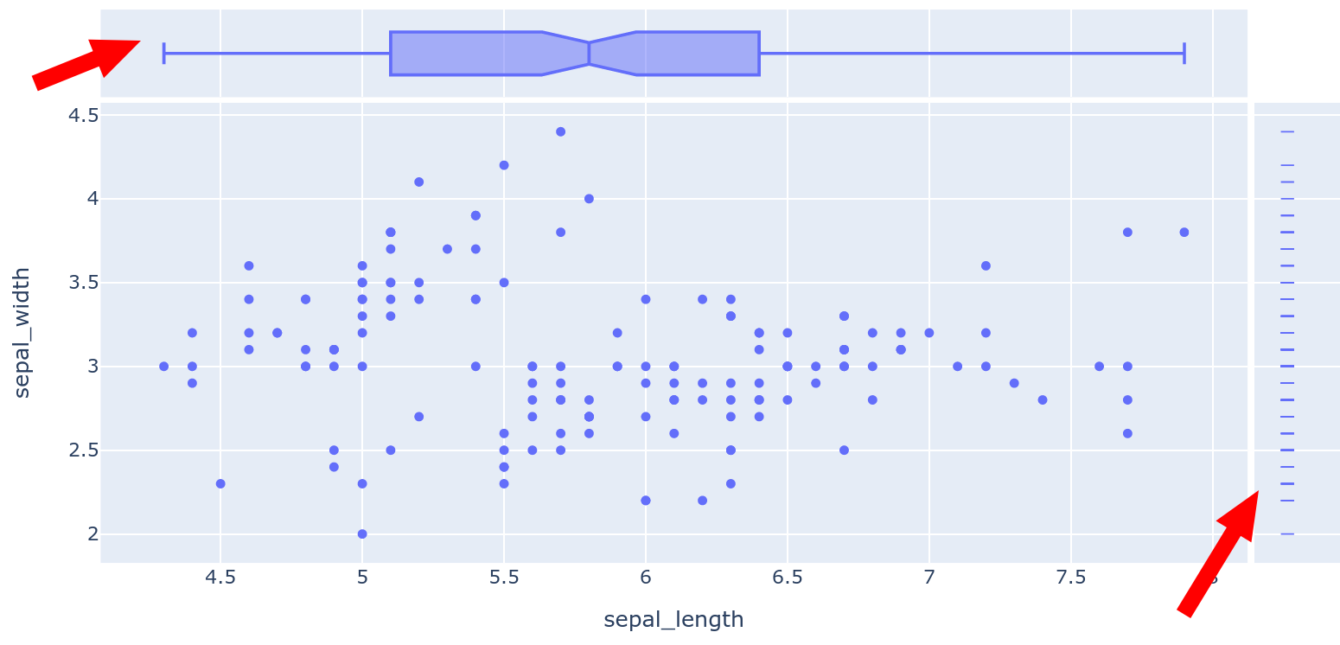  px.scatter(df, x="dataX", y="dataY", marginal_x="box", marginal_y="rug")  // box, rug, violin, histogram
Scatter Plot with facets (= split plot by value)  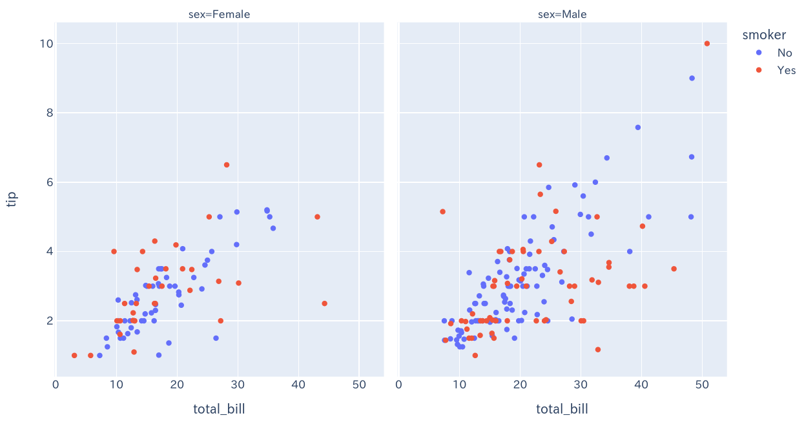  px.scatter(df, x="total_bill", y="tip", color="smoker", facet_col="sex") | Scatter plot with trendline  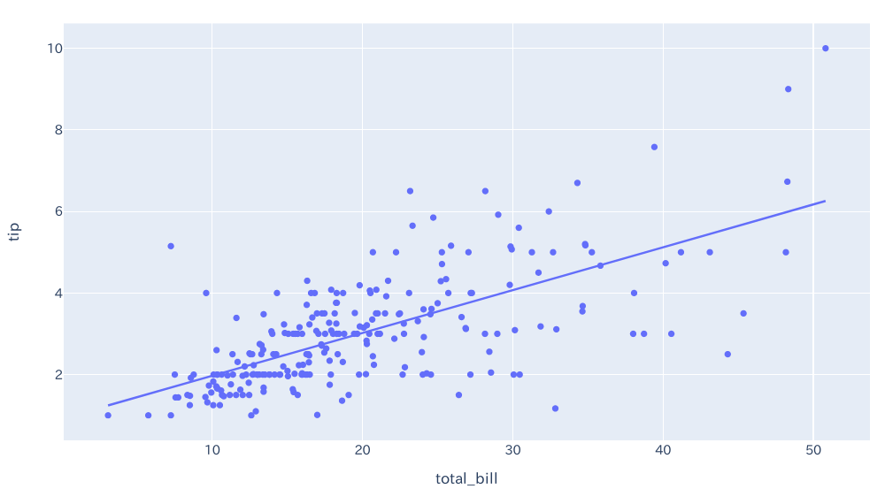  fig = px.scatter(df, x="total_bill", y="tip", trendline="ols")
line plot  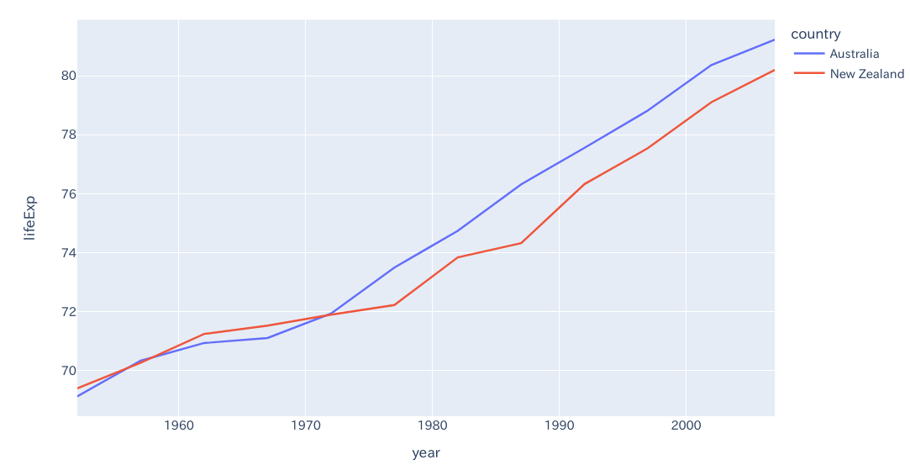  px.line(df, x='year', y='lifeExp', color='country')  // ‘color’ will enable grouping by that column | line plot with markers  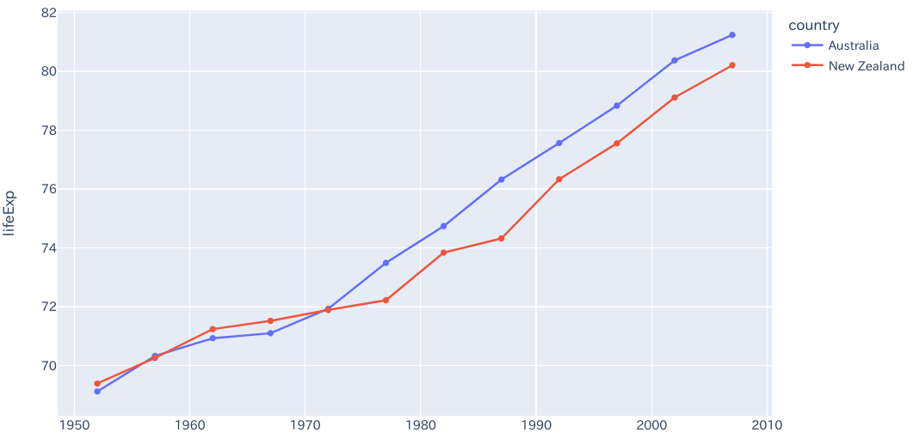  px.line(df, x='year', y='lifeExp', color='country', markers=True)  // ‘color’ will enable grouping by that column
Graph with text below points  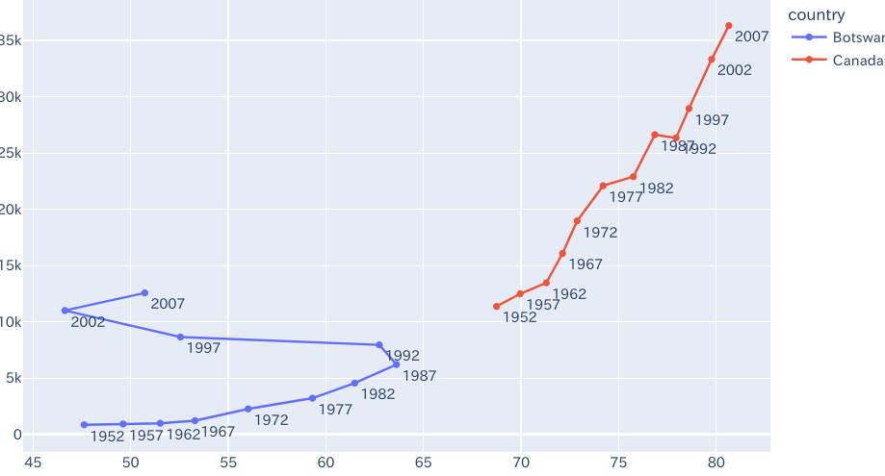  fig = px.line(df, x="colX", y="colY", color="country", text="year")  fig.update_traces(textposition="bottom right") | Several independent graphs in one plane  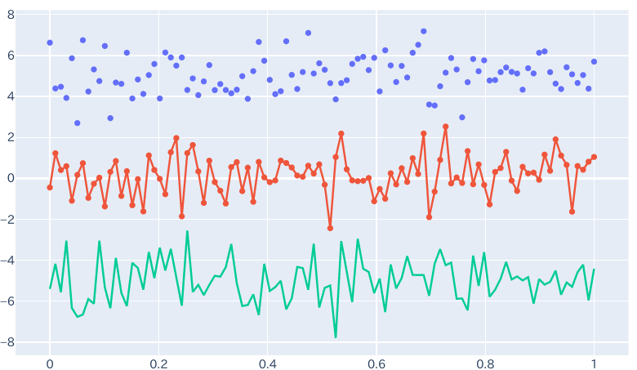  fig = go.Figure()  fig.add_trace(go.Scatter(x=[1,2],y=[4,8])
Scatter plot with a color dimension
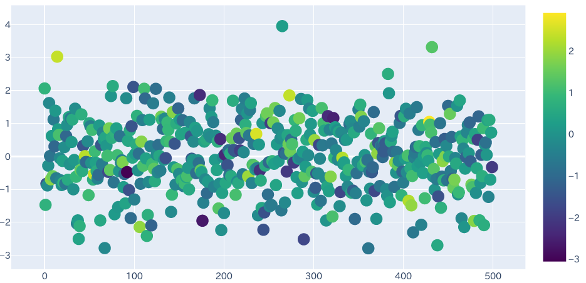
fig = go.Figure(data=go.Scatter(y = [1,2,3,4],
mode='markers', marker=dict (size=16, color=[1,2,3,4], colorscale='Viridis', showscale=True)))

Bar charts
basic bar chart  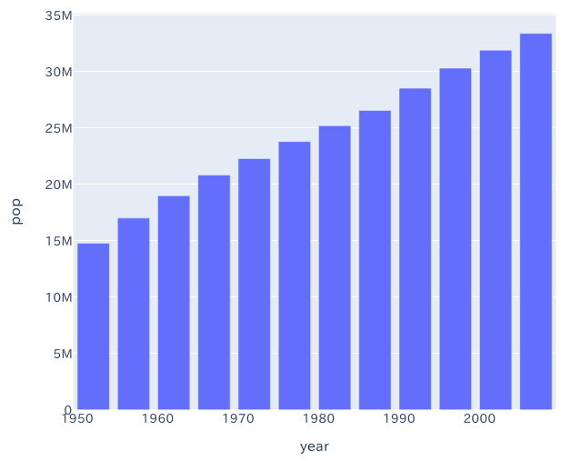  px.bar(x=[1,2,3,4], y=[4,3,2,1]).show() | Stacked bar chart  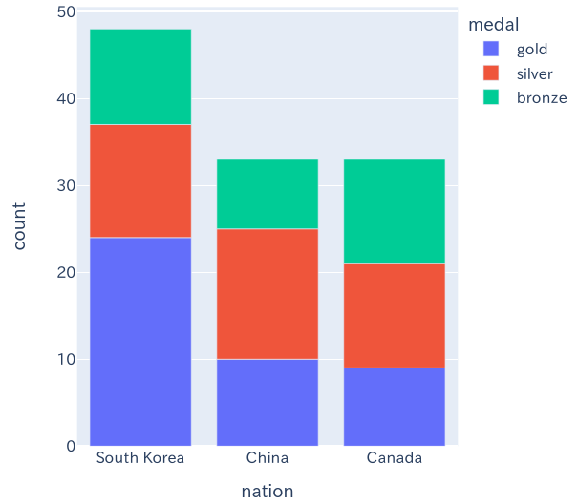  px.bar(df, x="nation", y="colY", color="medal")  Add Text:  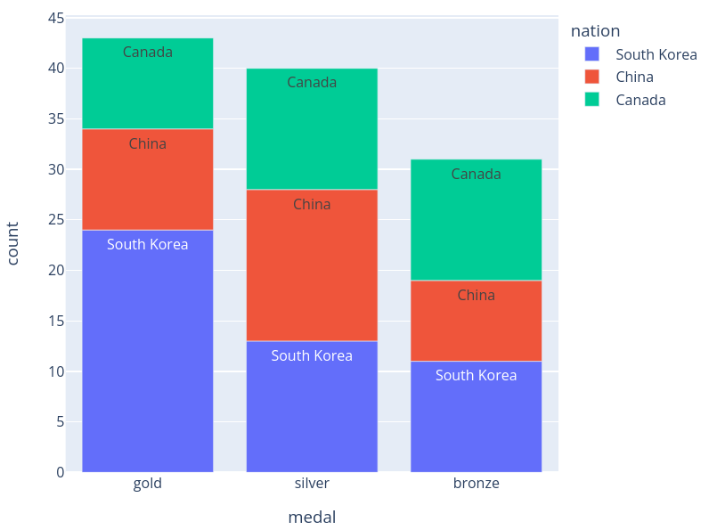  px.bar(df, x="medal", y="count", color="nation", text="nation")
Colored Bars  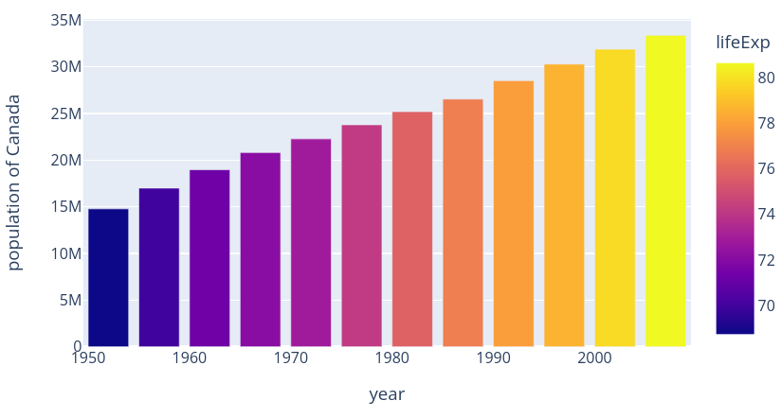  px.bar(df, x='year', y='pop',  hover_data=['lifeExp', 'gdpPercap'], color='lifeExp',  labels={'pop':'population of Canada'}, height=400) | Colored Bars 2  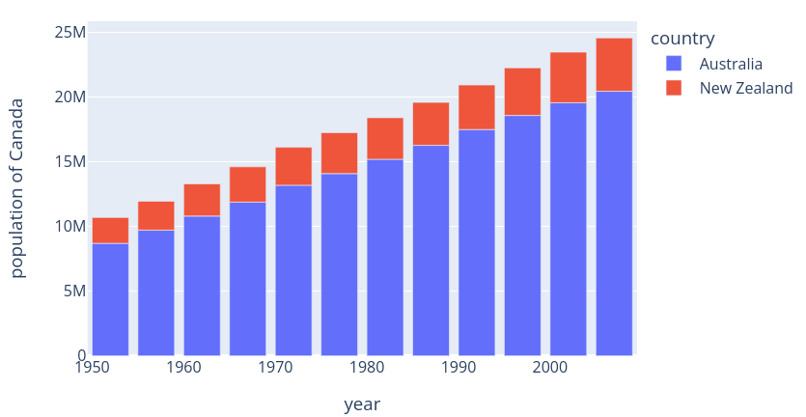  px.bar(df, x='year', y='pop',  hover_data=['lifeExp', 'gdpPercap'], color='country',  labels={'pop':'population of Canada'}, height=400)
Stacked Bar Chart  (When several rows share the same value of x (here Female or Male), the rectangles are stacked on top of one another by default.)  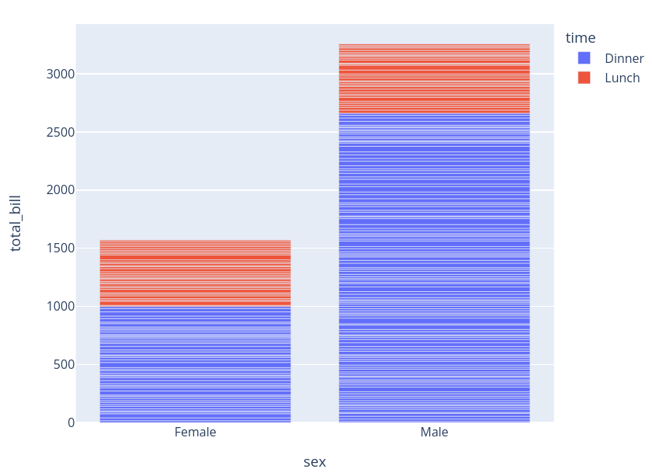  px.bar(df, x="sex", y="total_bill", color='time') | Grouped Bar Chart  (=Stacked + Grouped(=divided))  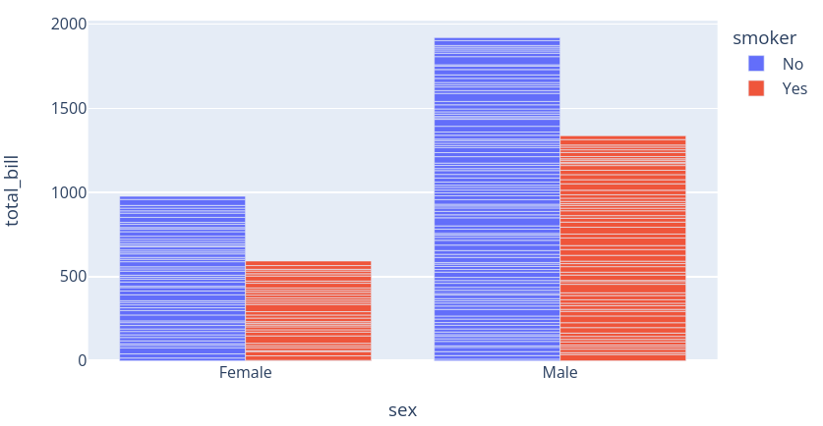  px.bar(df, x="sex", y="total_bill", color='smoker', barmode='group', height=400)
Basic Histogram  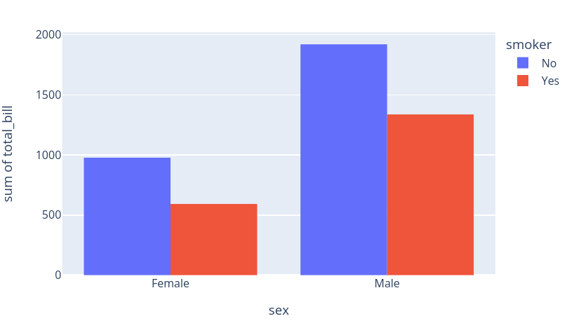  px.histogram(df, x="sex", y="total_bill",  color='smoker', barmode='group',  height=400) | Basic Bar Chart with Text Inside  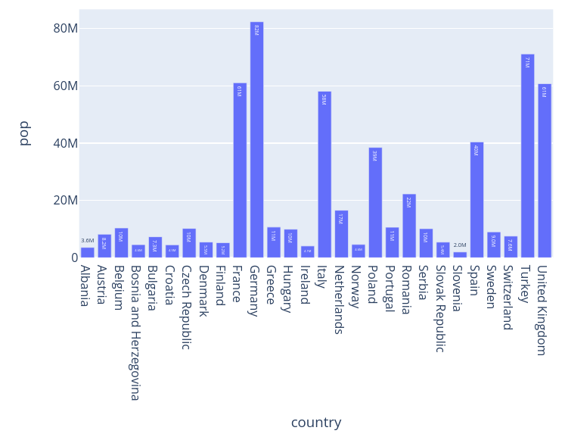  px.bar(df, y='pop', x='country', text_auto='.2s',  title="Default: various text sizes, positions and angles")
Basic Bar Chart with Text outside  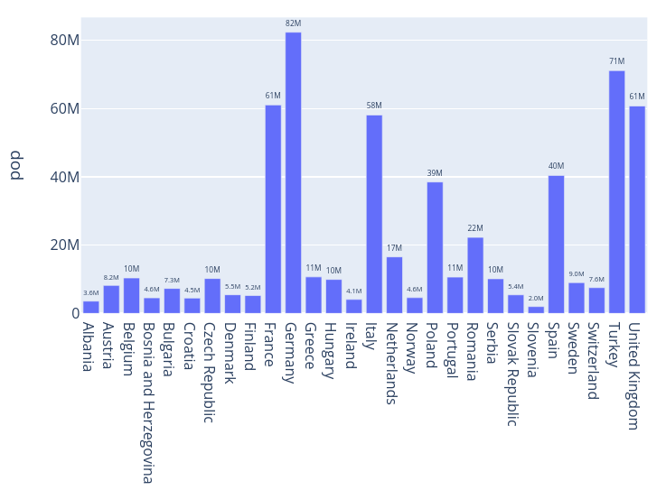  fig = px.bar(df, y='pop', x='country', text_auto='.2s',  title="Controlled text sizes, positions and angles")  fig.update_traces(textfont_size=12, textangle=0, textposition="outside", cliponaxis=False) | Inner Patterns  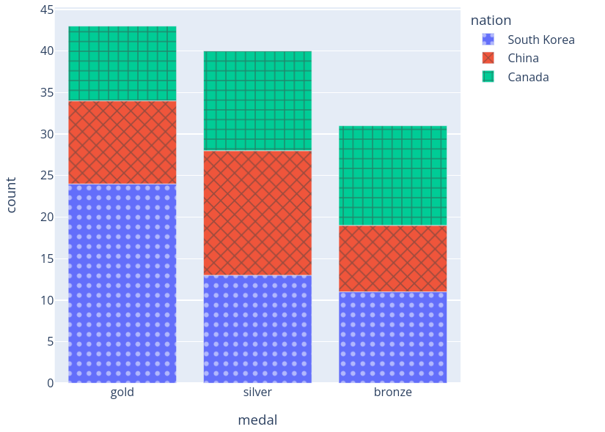  px.bar(df, x="medal", y="count", color="nation",  pattern_shape="nation", pattern_shape_sequence=[".", "x", "+"])
Facetted subplots  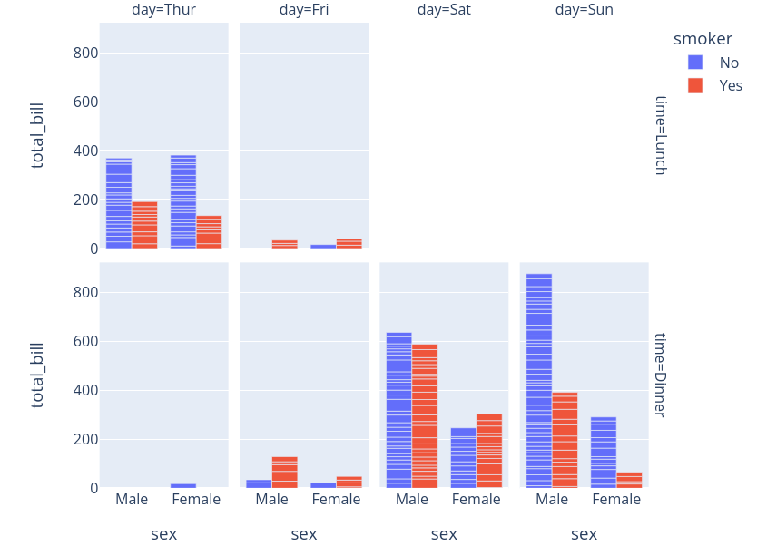  px.bar(df, x="sex", y="total_bill", color="smoker", barmode="group",  facet_row="time", facet_col="day",  category_orders={"day": ["Thur", "Fri", "Sat", "Sun"],  "time": ["Lunch", "Dinner"]}) | Special coloring  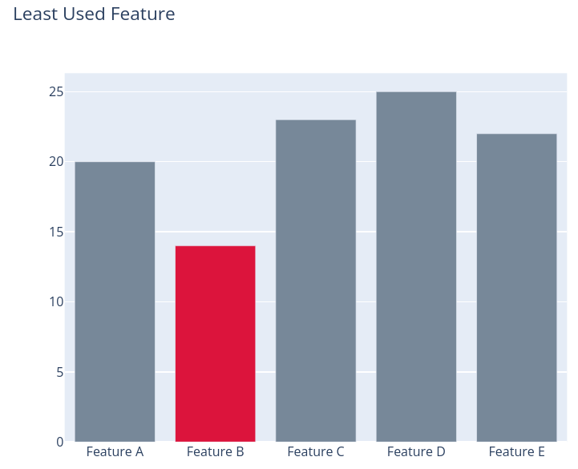  colors = ['lightslategray',] * 5  colors[1] = 'crimson'  fig = go.Figure(data=[go.Bar(  x=['Feature A', 'Feature B', 'Feature C',  'Feature D', 'Feature E'],  y=[20, 14, 23, 25, 22],  marker_color=colors # marker color can be a single color value or an iterable  )])  fig.update_layout(title_text='Least Used Feature')
Individual Bar Width  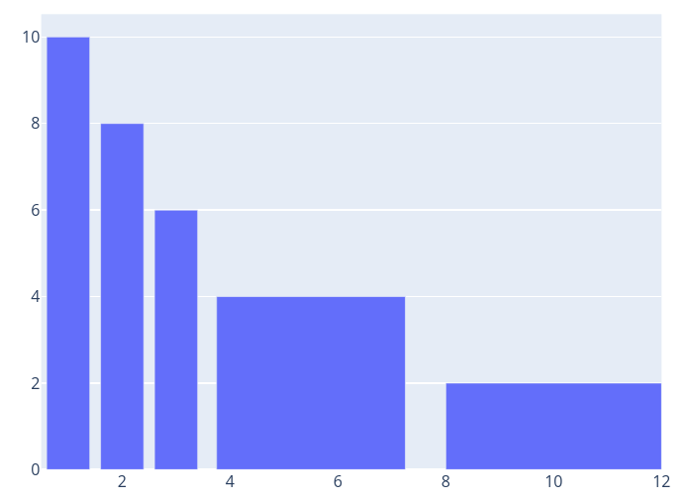  go.Figure(data=[go.Bar(  x=[1, 2, 3, 5.5, 10],  y=[10, 8, 6, 4, 2],  width=[0.8, 0.8, 0.8, 3.5, 4] # customize width here  )]) | Continuously Build up Diagram /  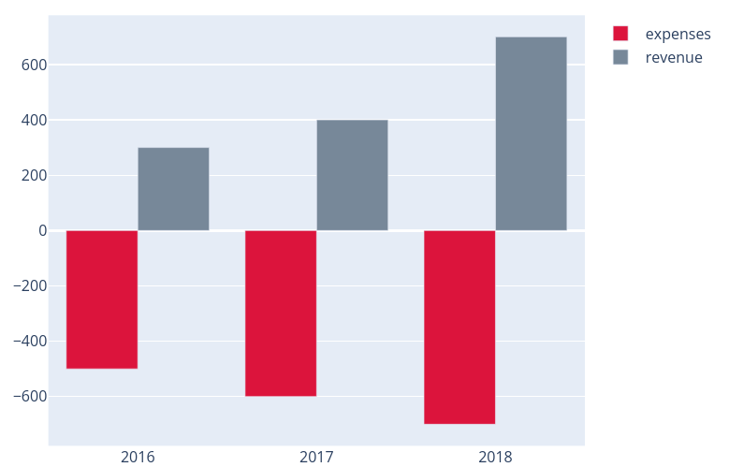  years = ['2016','2017','2018']  fig = go.Figure()  fig.add_trace(go.Bar(x=years, y=[500, 600, 700],  base=[-500,-600,-700],  marker_color='crimson',  name='expenses'))  fig.add_trace(go.Bar(x=years, y=[300, 400, 700],  base=0,  marker_color='lightslategrey',  name='revenue'  ))
Fancy formatting  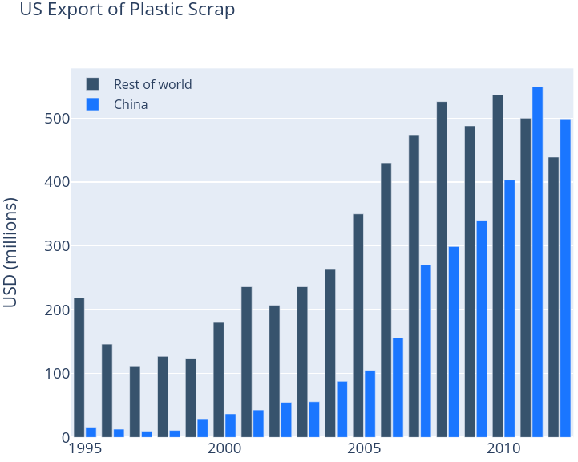  years = [1995, 1996, 1997, 1998, 1999, 2000, 2001, 2002, 2003,  2004, 2005, 2006, 2007, 2008, 2009, 2010, 2011, 2012]  fig = go.Figure()  fig.add_trace(go.Bar(x=years,  y=[219, 146, 112, 127, 124, 180, 236, 207, 236, 263,  350, 430, 474, 526, 488, 537, 500, 439],  name='Rest of world',  marker_color='rgb(55, 83, 109)'  ))  fig.add_trace(go.Bar(x=years,  y=[16, 13, 10, 11, 28, 37, 43, 55, 56, 88, 105, 156, 270,  299, 340, 403, 549, 499],  name='China',  marker_color='rgb(26, 118, 255)'  ))  fig.update_layout(  title='US Export of Plastic Scrap',  xaxis_tickfont_size=14,  yaxis=dict(  title='USD (millions)',  titlefont_size=16,  tickfont_size=14,  ),  legend=dict(  x=0,  y=1.0,  bgcolor='rgba(255, 255, 255, 0)',  bordercolor='rgba(255, 255, 255, 0)'  ),  barmode='group',  bargap=0.15, # gap between bars of adjacent location coordinates.  bargroupgap=0.1 # gap between bars of the same location coordinate.  ) | Relative Bar Mode  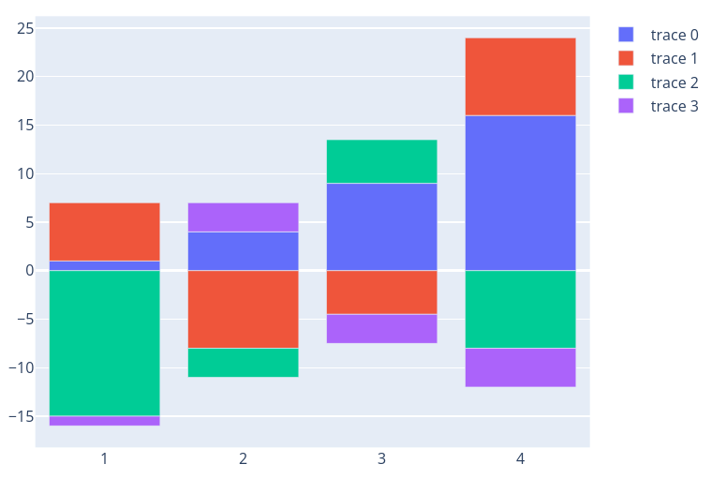  x = [1, 2, 3, 4]  fig = go.Figure()  fig.add_trace(go.Bar(x=x, y=[1, 4, 9, 16]))  fig.add_trace(go.Bar(x=x, y=[6, -8, -4.5, 8]))  fig.add_trace(go.Bar(x=x, y=[-15, -3, 4.5, -8]))  fig.add_trace(go.Bar(x=x, y=[-1, 3, -3, -4]))  fig.update_layout(barmode='relative', title_text='Relative Barmode')
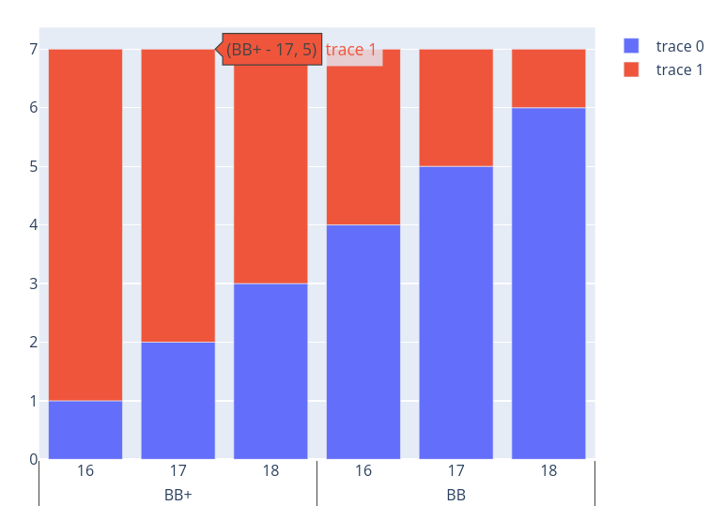  x = [  ["BB+", "BB+", "BB+", "BB", "BB", "BB"],  [16, 17, 18, 16, 17, 18,]  ]  fig = go.Figure()  fig.add_bar(x=x,y=[1,2,3,4,5,6])  fig.add_bar(x=x,y=[6,5,4,3,2,1])  fig.update_layout(barmode="relative") | Horizontal Bar Chart  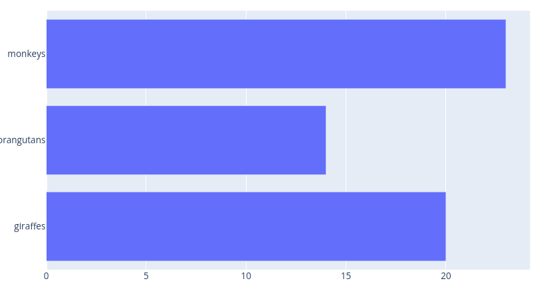  go.Figure(go.Bar(x=[20, 14, 23],y=['giraffes', 'orangutans', 'monkeys'],orientation='h'))
Gantt Chart  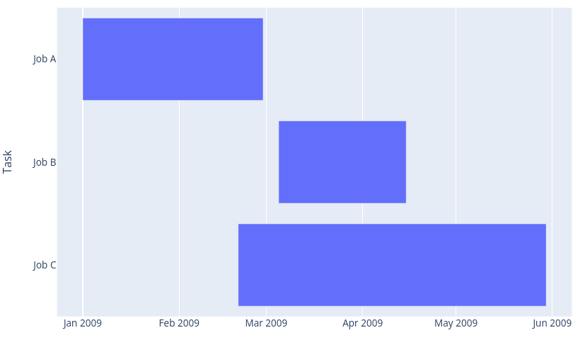  df = pd.DataFrame([  dict(Task="Job A", Start='2009-01-01', Finish='2009-02-28'),  dict(Task="Job B", Start='2009-03-05', Finish='2009-04-15'),  dict(Task="Job C", Start='2009-02-20', Finish='2009-05-30')  ])  fig = px.timeline(df, x_start="Start", x_end="Finish", y="Task")  fig.update_yaxes(autorange="reversed") # otherwise tasks are listed from the bottom up | Gantt Chart with Coloring  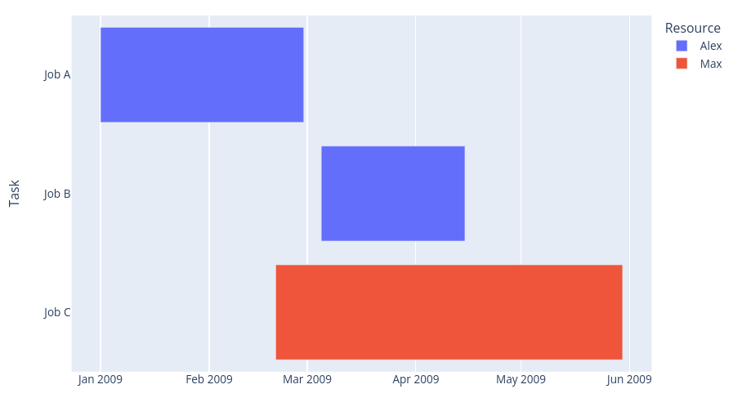  df = pd.DataFrame([  dict(Task="Job A", Start='2009-01-01', Finish='2009-02-28', Resource="Alex"),  dict(Task="Job B", Start='2009-03-05', Finish='2009-04-15', Resource="Alex"),  dict(Task="Job C", Start='2009-02-20', Finish='2009-05-30', Resource="Max")  ])  fig = px.timeline(df, x_start="Start", x_end="Finish", y="Task", color="Resource")  fig.update_yaxes(autorange="reversed")
Gantt Chart with grouping  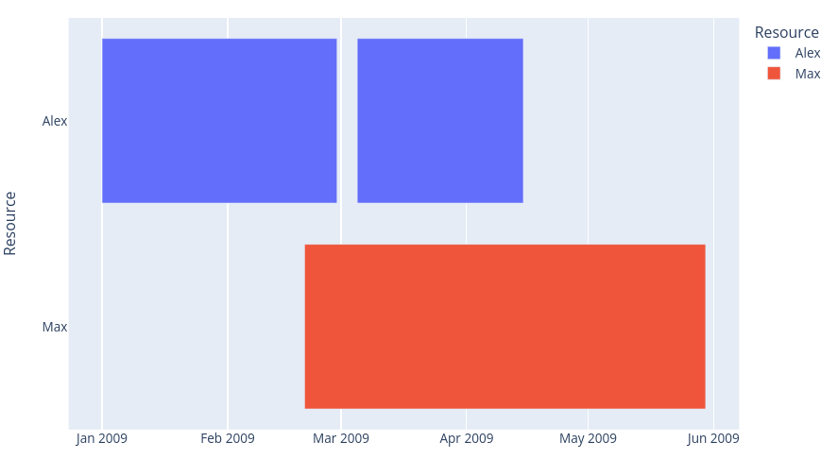  df = pd.DataFrame([  dict(Task="Job A", Start='2009-01-01', Finish='2009-02-28', Resource="Alex"),  dict(Task="Job B", Start='2009-03-05', Finish='2009-04-15', Resource="Alex"),  dict(Task="Job C", Start='2009-02-20', Finish='2009-05-30', Resource="Max")  ])  fig = px.timeline(df, x_start="Start", x_end="Finish", y="Resource", color="Resource") | Gantt Chart with grouping 2  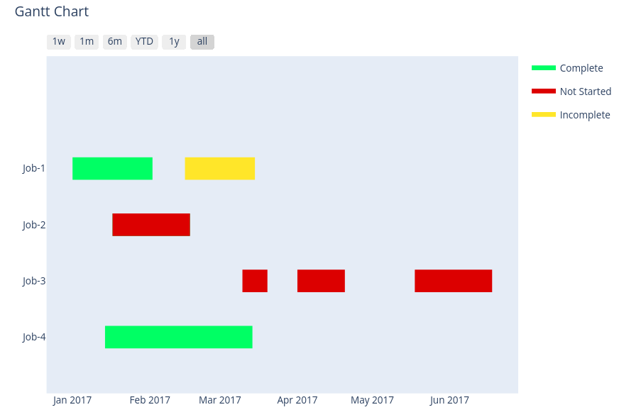  ff.create_gantt(df, colors=colors, index_col='Resource',show_colorbar=True,group_tasks=True)
Box plot with error  (https://plotly.com/python/categorical-axes/)  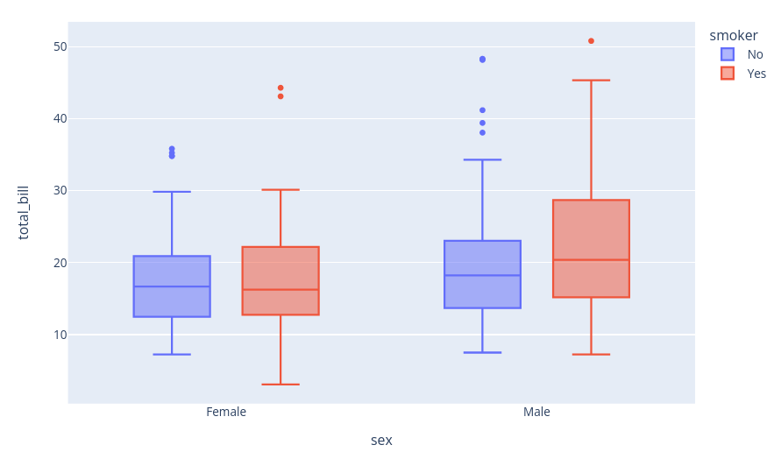  px.box(df, x="sex", y="total_bill", color="smoker") | Violin Plot  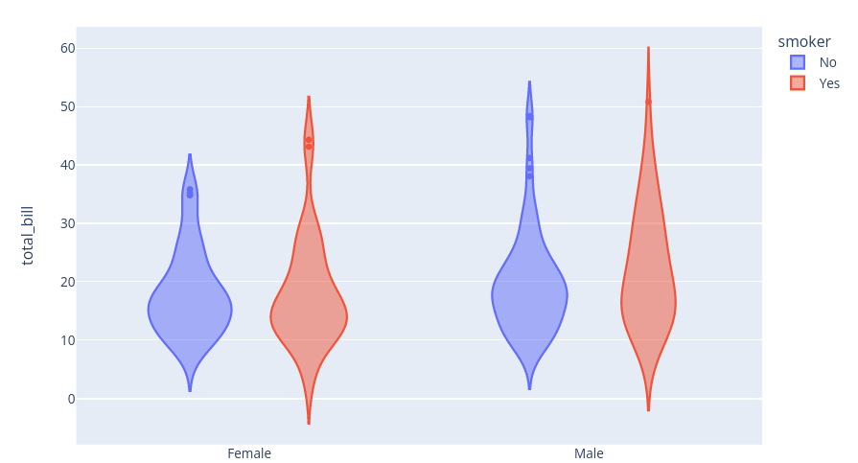  px.violin(df, x="sex", y="total_bill", color="smoker")

Pie Charts
General Pie Chart  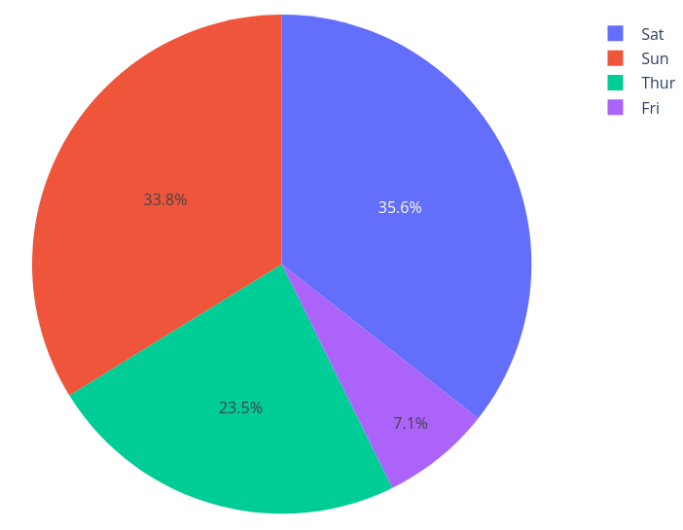  px.pie(df, values='tip', names='day') | Pie Chart with Dropdown  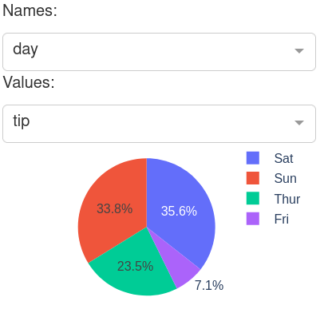  https://plotly.com/python/pie-charts/#pie-chart-in-dash
Setting colors (automatic)  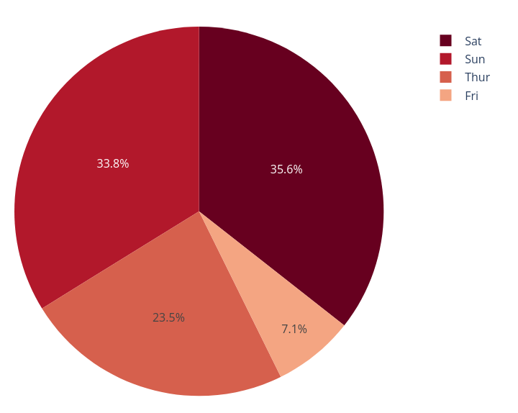  px.pie(df, values='tip', names='day', color_discrete_sequence=px.colors.sequential.RdBu) | Setting colors (manual)  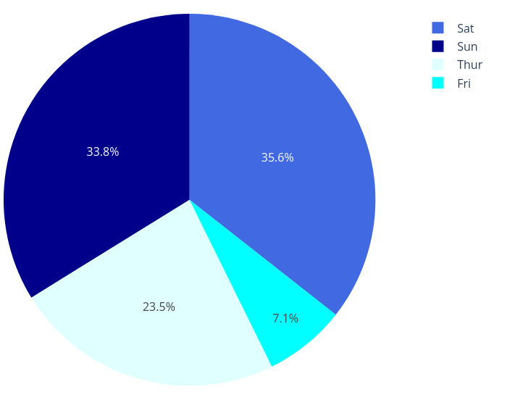  px.pie(df, values='tip', names='day', color='day',  color_discrete_map={'Thur':'lightcyan','Fri':'cyan',Sat':'royalblue',Sun':'darkblue'})
Customized Pie Chart  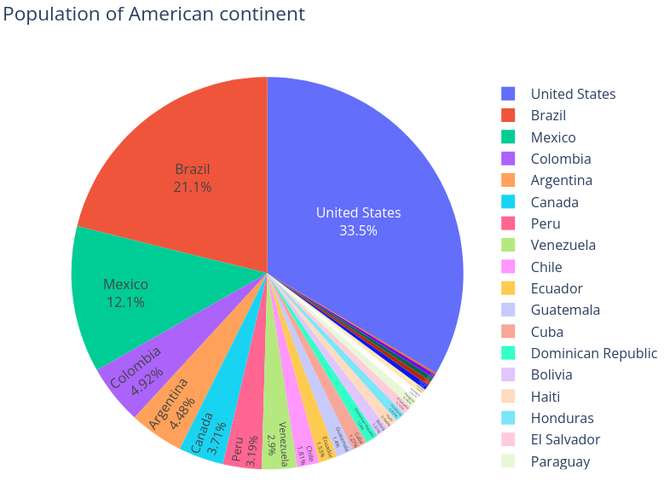  px.pie(df, values='pop', names='country',  title='Population of American continent',  hover_data=['lifeExp'], labels={'lifeExp':'life expectancy'})  fig.update_traces(textposition='inside', textinfo='percent+label') | Radial Text Orientation  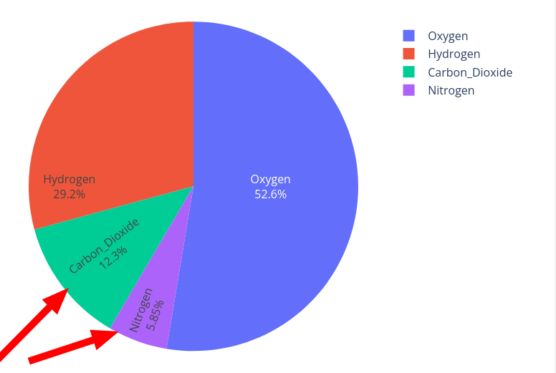  go.Figure(data=[go.Pie(labels=labels, values=values, textinfo='label+percent',  insidetextorientation='radial'  )])
Sticking out Piece
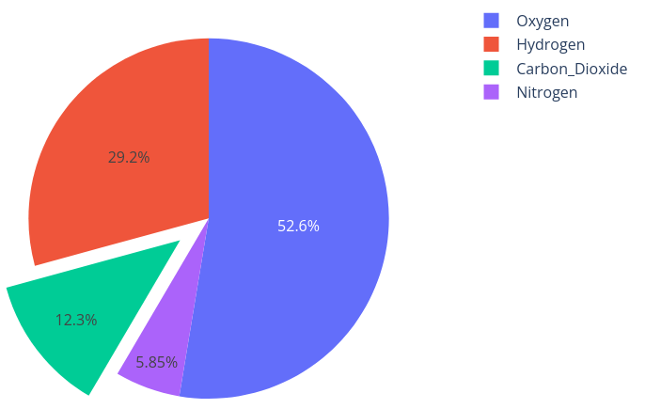
# pull is given as a fraction of the pie radius
fig = go.Figure(data=[go.Pie(labels=labels, values=values, pull=[0, 0, 0.2, 0])])

Doughnut Chart
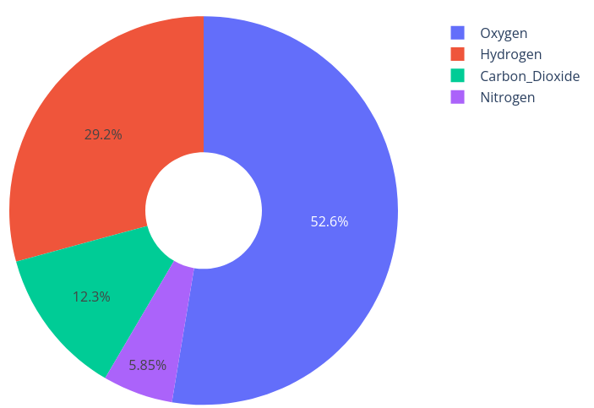
go.Figure(data=[go.Pie(labels=labels, values=values, hole=.3)])

Fancy Doughnut
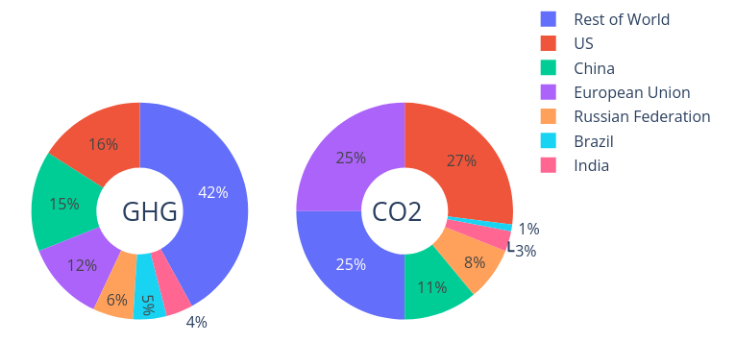
https://plotly.com/python/pie-charts/#pie-charts-in-subplots

Sunburst Charts
(will move on click)
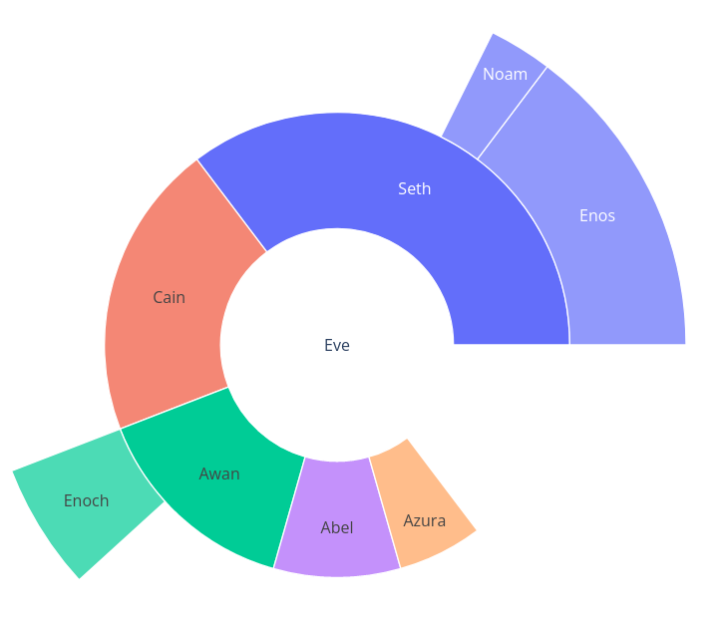
go.Figure(go.Sunburst(
labels=["Eve", "Cain", "Seth", "Enos", "Noam",
"Abel", "Awan", "Enoch", "Azura"],
parents=["", "Eve", "Eve", "Seth", "Seth",
"Eve", "Eve", "Awan", "Eve" ],
values=[10, 14, 12, 10, 2, 6, 6, 4, 4],
))
fig.update_layout(margin = dict(t=0, l=0, r=0, b=0))

Sunburst Diagram: Data structure
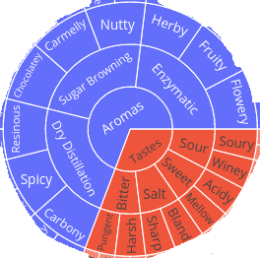

id parent label
-------------------------------------------------
Aromas NaN [whatever is shown]
Tastes NaN [whatever is shown]

dry-distillation Aromas [whatever is shown]
sugar-browning Aromas [whatever is shown]
enzymatic Aromas [whatever is shown]

Tastes Sour [whatever is shown]
Sweet Sour [whatever is shown]
Salt Sour [whatever is shown]
Bitter Sour [whatever is shown]

https://plotly.com/python/sunburst-charts/#large-number-of-slices

Coloring depending on some value
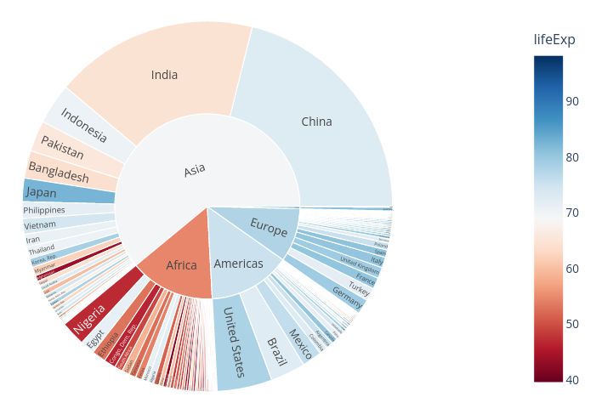
px.sunburst(df, path=['continent', 'country'], values='pop',
color='lifeExp', hover_data=['iso_alpha'],
color_continuous_scale='RdBu',
color_continuous_midpoint=np.average(df['lifeExp'], weights=df['pop']))

Treemap / Rectangular sunburst
Rectangular sunburst / Treemap
( https://plotly.com/python/treemaps/ )
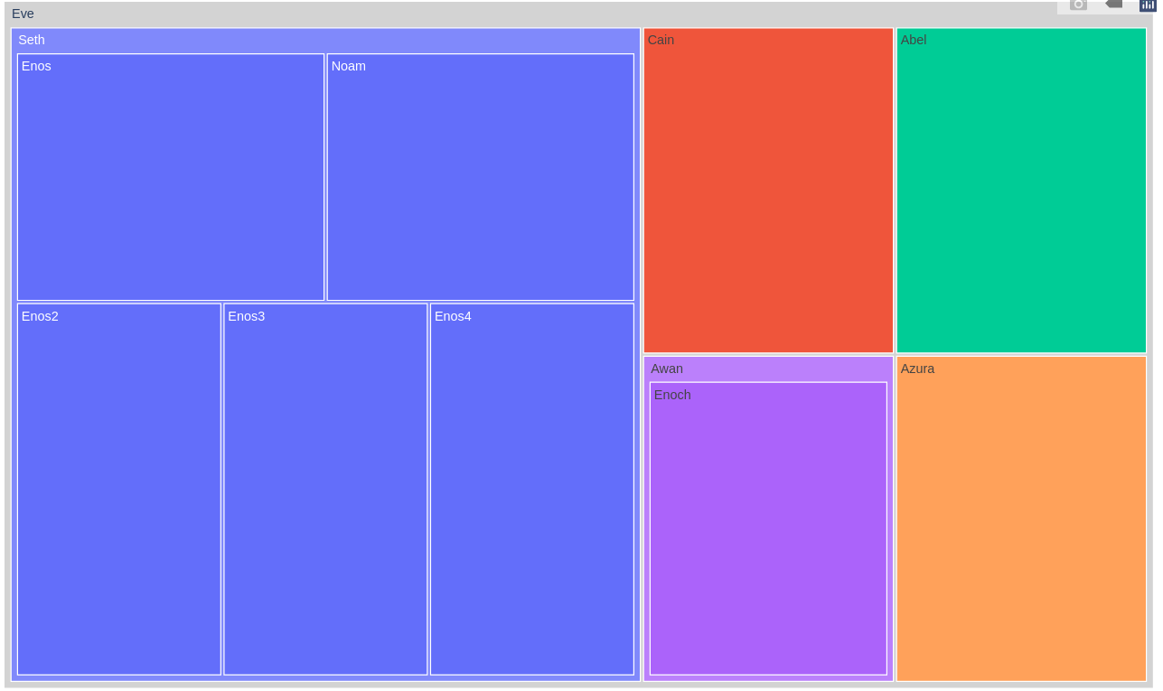
fig = px.treemap(
names = ["Eve","Cain", "Seth", "Enos", "Noam", "Abel", "Awan", "Enoch", "Azura", "Enos2", "Enos3", "Enos4"],
parents = ["", "Eve", "Eve", "Seth", "Seth", "Eve", "Eve", "Awan", "Eve", "Seth", "Seth", "Seth"]
)
fig.update_traces(root_color="lightgrey")
fig.update_layout(margin = dict(t=10, l=10, r=10, b=10))
fig.show()

Treemap examples
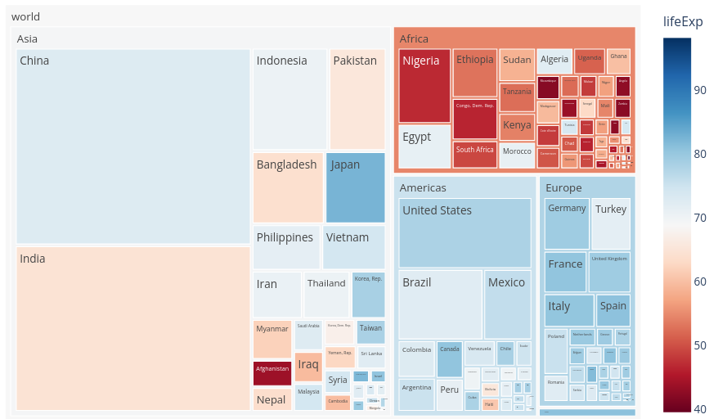

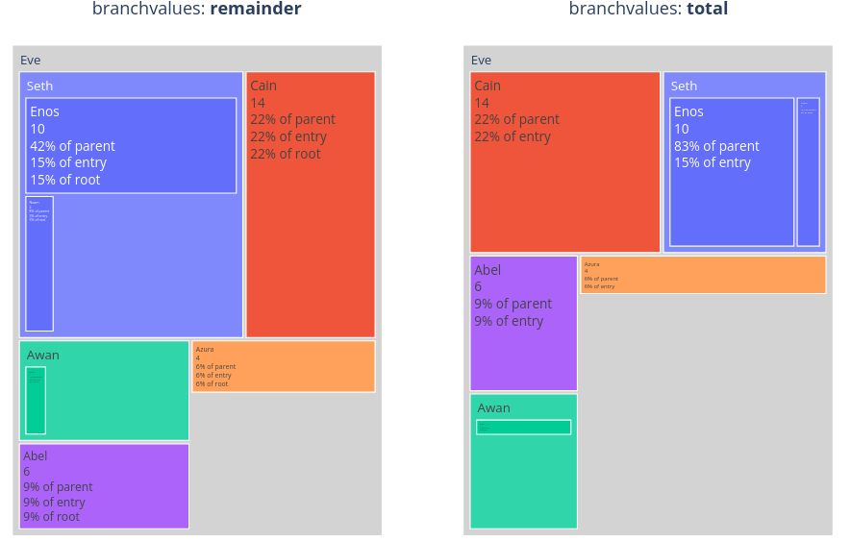
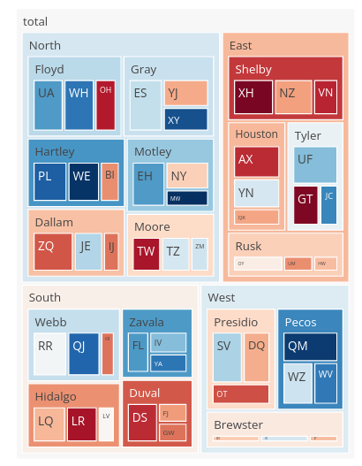

Treemap saturating colors
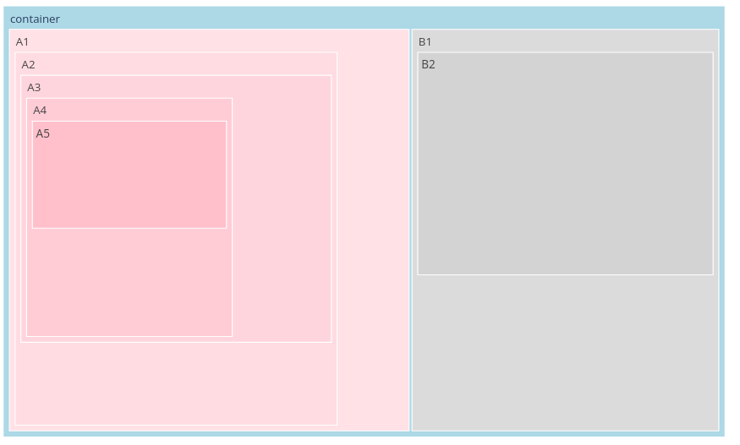
values = [0, 11, 12, 13, 14, 15, 20, 30]
labels = ["container", "A1", "A2", "A3", "A4", "A5", "B1", "B2"]
parents = ["", "container", "A1", "A2", "A3", "A4", "container", "B1"]

fig = go.Figure(go.Treemap(
labels = labels,
values = values,
parents = parents,
marker_colorscale = 'Blues'
))

fig.update_layout(margin = dict(t=50, l=25, r=25, b=25))

Horizontal Treemap
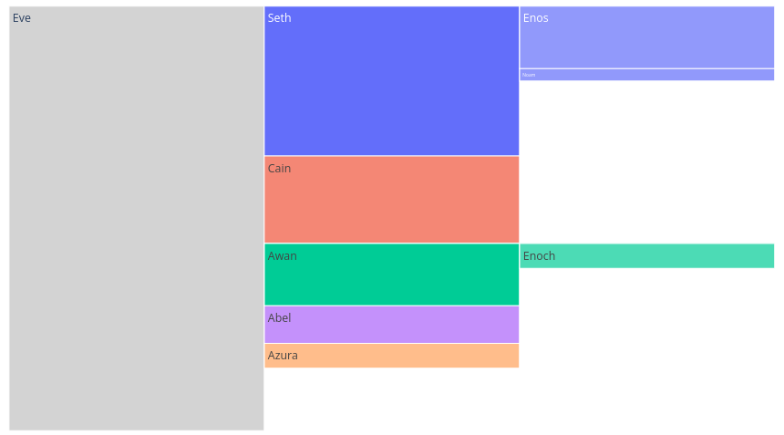
data = dict(
character=["Eve", "Cain", "Seth", "Enos", "Noam", "Abel", "Awan", "Enoch", "Azura"],
parent=["", "Eve", "Eve", "Seth", "Seth", "Eve", "Eve", "Awan", "Eve" ],
value=[10, 14, 12, 10, 2, 6, 6, 4, 4])

fig =px.icicle(
data,
names='character',
parents='parent',
values='value',
)
fig.update_traces(root_color="lightgrey")
fig.update_layout(margin = dict(t=50, l=25, r=25, b=25))

Icicle Chart
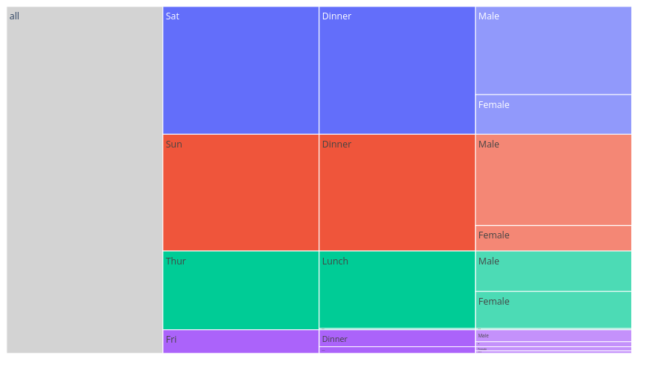
fig = px.icicle(df, path=[px.Constant("all"), 'day', 'time', 'sex'], values='total_bill')
fig.update_traces(root_color="lightgrey")
fig.update_layout(margin = dict(t=50, l=25, r=25, b=25))
fig.show()

Icicle Chart – repeated labels
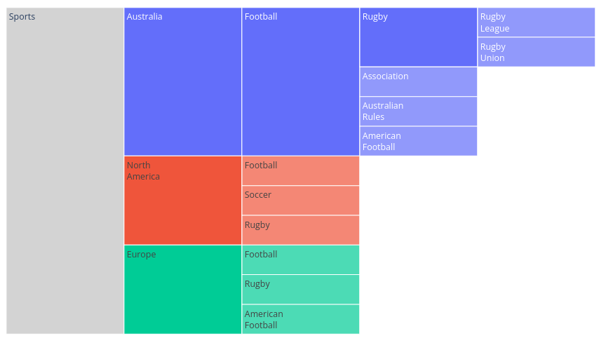
https://plotly.com/python/icicle-charts/#icicle-with-repeated-labels

Further examples:
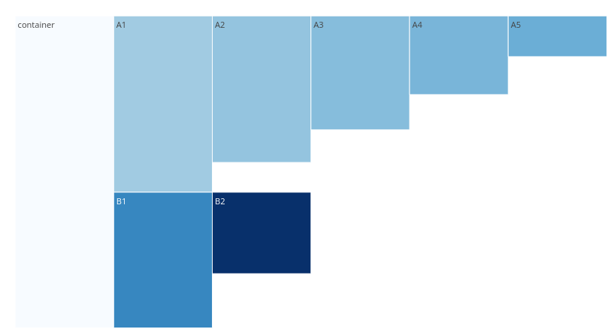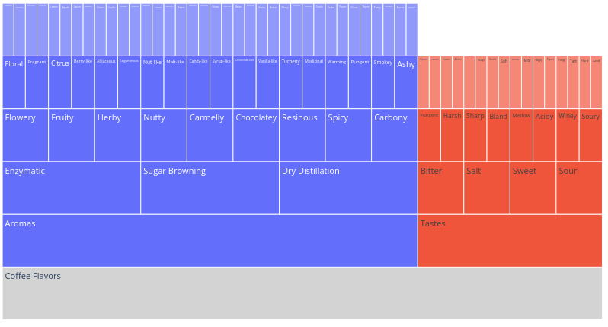
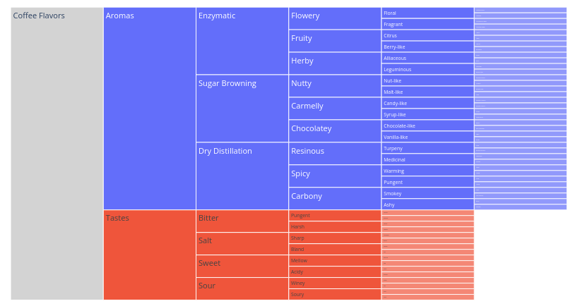

Bubble Charts
General  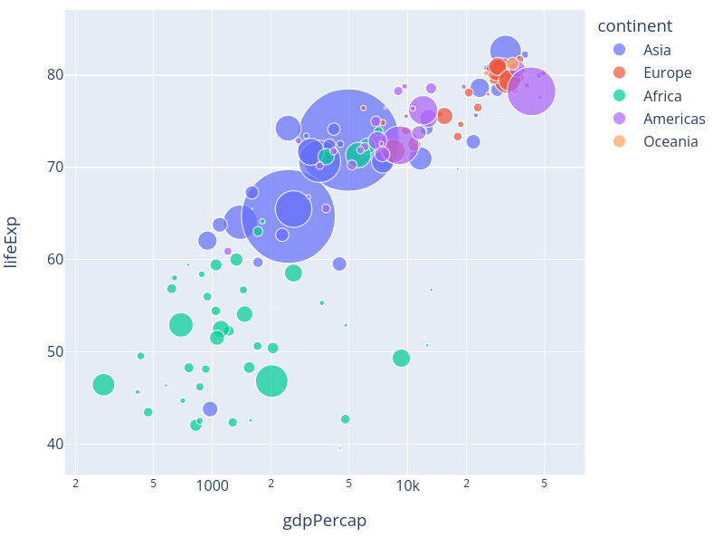  px.scatter(df.query("year==2007"), x="gdpPercap", y="lifeExp",  size="pop", color="continent",  hover_name="country", log_x=True, size_max=60) | Bubble Chart individual colors  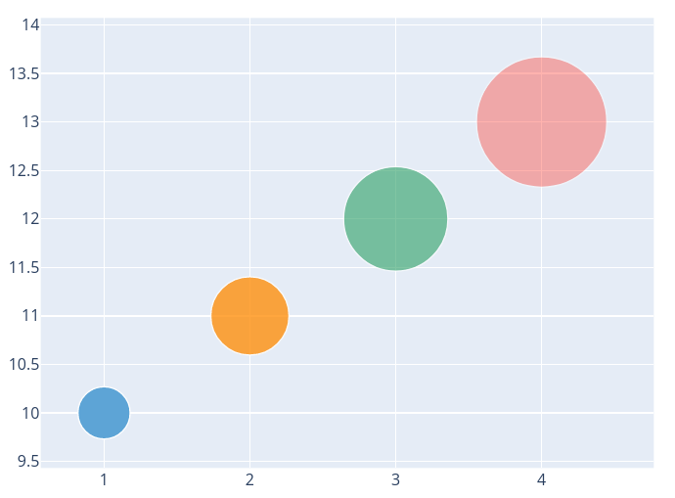  go.Figure(data=[go.Scatter(  x=[1, 2, 3, 4], y=[10, 11, 12, 13],  mode='markers',  marker=dict(color=['rgb(93, 164, 214)', 'rgb(255, 144, 14)','rgb(44, 160, 101)', 'rgb(255, 65, 54)'],opacity=[1, 0.8, 0.6, 0.4],size =[40, 60, 80, 100],  )  )])
Individual Sizes  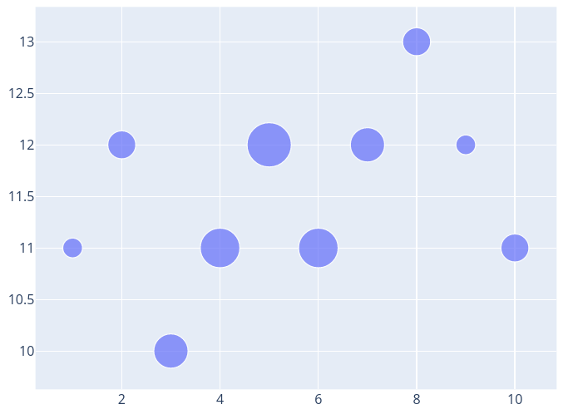  size = [20, 40, 60, 80, 100, 80, 60, 40, 20, 40]  fig = go.Figure(data=[go.Scatter(  x=[1, 2, 3, 4, 5, 6, 7, 8, 9, 10],  y=[11, 12, 10, 11, 12, 11, 12, 13, 12, 11],  mode='markers',  marker=dict(  size=size,  sizemode='area',  sizeref=2.*max(size)/(40.**2),  sizemin=4  )  )]) | Bubble Charts with Colorscale  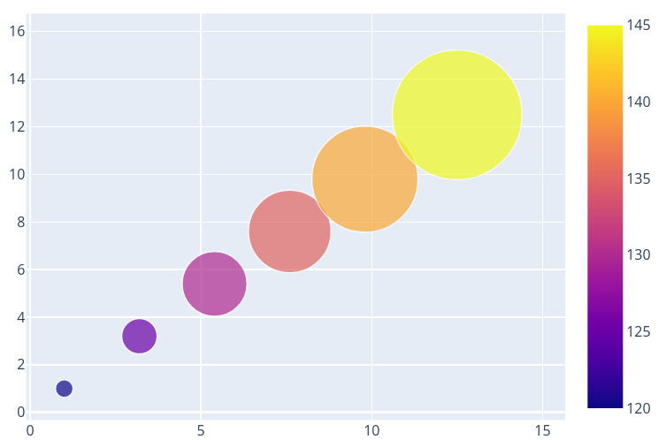  fig = go.Figure(data=[go.Scatter(  x=[1, 3.2, 5.4, 7.6, 9.8, 12.5],  y=[1, 3.2, 5.4, 7.6, 9.8, 12.5],  mode='markers',  marker=dict(  color=[120, 125, 130, 135, 140, 145],  size=[15, 30, 55, 70, 90, 110],  showscale=True  )  )])

Dot Charts

Basic Dot Chart  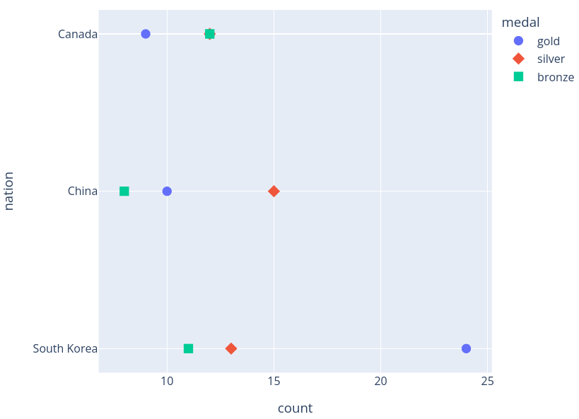  fig = px.scatter(df, y="nation", x="count", color="medal", symbol="medal")  fig.update_traces(marker_size=10) | 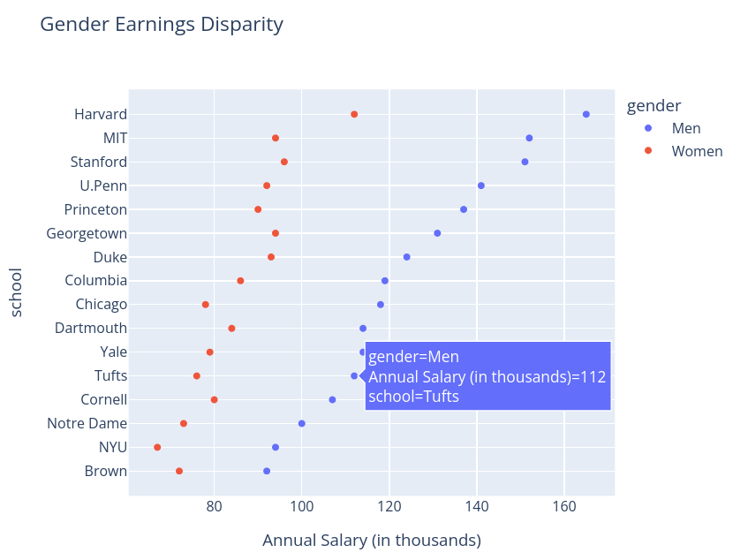  https://plotly.com/python/dot-plots/
Styled Categorical Dot Plot
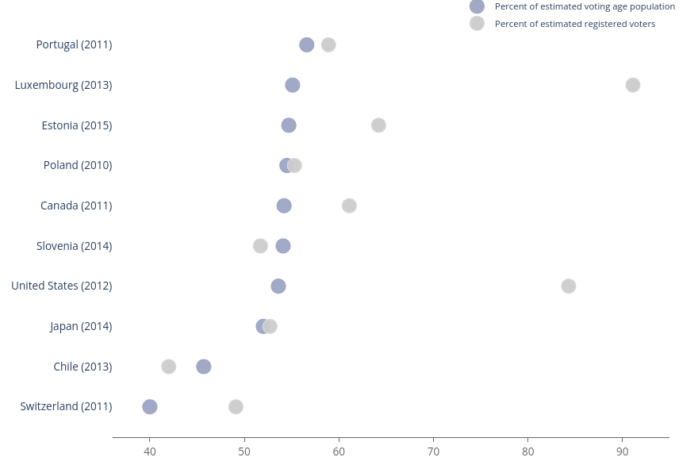
https://plotly.com/python/dot-plots/#styled-categorical-dot-plot

Filled Area Plots
https://plotly.com/python/filled-area-plots/
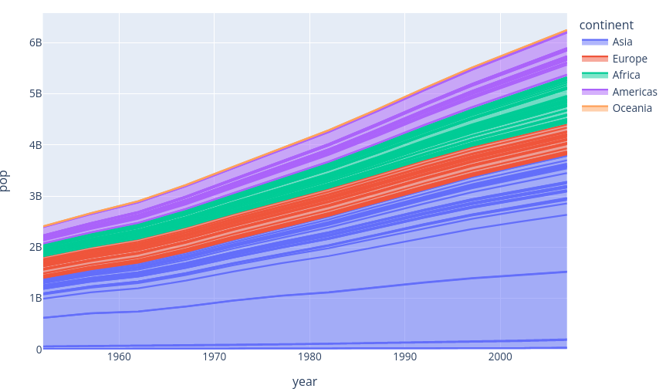  px.area(df, x="year", y="pop", color="continent",  line_group="country") | 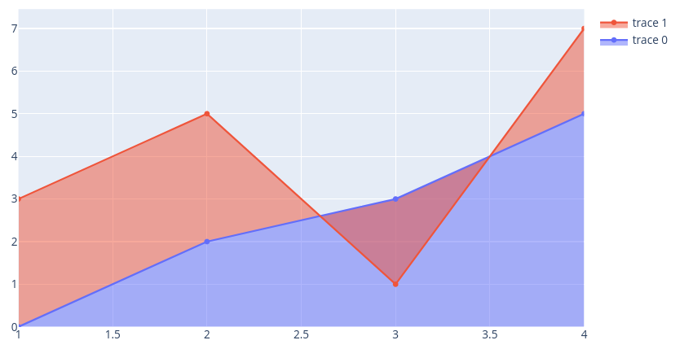  go.Figure()  fig.add_trace(go.Scatter(x=[1, 2, 3, 4], y=[0, 2, 3, 5], fill='tozeroy')) # fill down to xaxis  fig.add_trace(go.Scatter(x=[1, 2, 3, 4], y=[3, 5, 1, 7], fill='tonexty')) # fill to trace0 y
Interior Filling for Area Chart  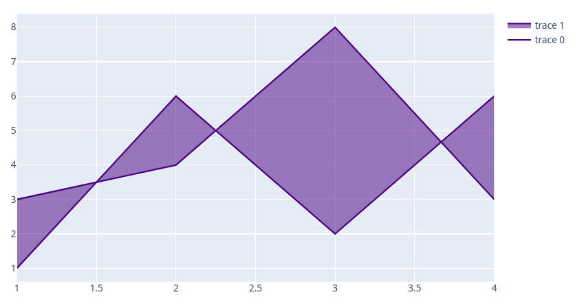  https://plotly.com/python/filled-area-plots/#interior-filling-for-area-chart | Stacked Area Chart  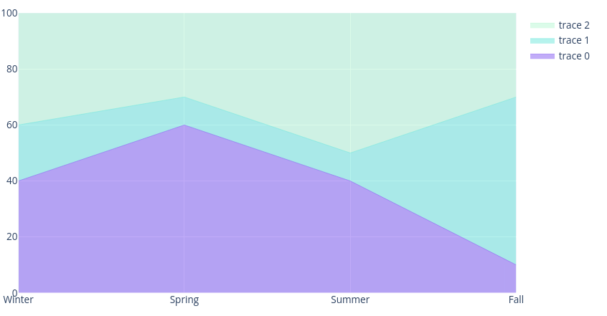  https://plotly.com/python/filled-area-plots/#stacked-area-chart

Others

Sankey Diagram:
https://plotly.com/python/sankey-diagram/
